**INSTALLATION GUIDE OF SELENIUM, JAVA, AND ECLIPSE:-->**

**JAVA AND ECLIPSE INSTALLATION GUIDE:**

1. Download JDK 19 from : [https://www.oracle.com/java/technologies/downloads/](https://www.oracle.com/java/technologies/downloads/" \t "https://desk.zoho.com/support/edurekain/ShowHomePage.do" \l "Cases/dv/_blank)

download Java SE Development Kit 19 Windows x64 Installer file.

Now select your operating system and click on the download link and “Accept License Agreement” to download the Java JDK 19 Installer file.



2.  Open the Java JDK installer file and it will open the installation wizard simply click on the “Next” button.



3. On the next window, you will get the option to change the installation location. You can change your installation location but I will suggest you keep it to default and click on “Next” to continue. After that, Java JDK will be installed on your Windows 11.



4. The installation process will take some time, so wait until the installation process is completes. After the installation process is completed just click on the “Close” button.



To run and compile Java code, we need to set the environment variable for the Java bin folder path.

To set up the Java JDK environment variable follow these steps:

Step 1: Open C Drive > Program Files folder and look for the Java folder and open it.

Step 2: Inside the Java folder you will find a JDK folder, open it and open the “bin folder“, and copy the path of the bin folder.

Note:- Now you have to set the environment variable.



Step 3: For that Go to Control Panel > System and Security > System > Advanced System Setting > Environment Variables.



Step 4: Under the System variable, you will find “PATH” just select it and click on edit. Now click on New and add the bin folder location, after that click on “OK“.



Now to check whether java is successfully installed or not open a command prompt and type  java -version” and “javac.”

If you find a bunch of statements in the command prompt, Java JDK is fully set up on your windows system.



**Please follow the step given below to install the latest version of Eclipse.**  
Steps-->

      1.  Download the Eclipse Installer

           Download Eclipse Installer from  [http://www.eclipse.org/downloads](http://www.eclipse.org/downloads" \t "https://desk.zoho.com/support/edurekain/ShowHomePage.do" \l "Cases/dv/_blank)

      2. Start the Eclipse Installer executable

          For Windows users, after the Eclipse Installer executable has finished downloading it should be available in your download

          directory. Start the Eclipse Installer executable. You may get a security warning to run this file. If the Eclipse Foundation is the

          Publisher, you are good to select Run.

          For Mac and Linux users, you will still need to unzip the download to create the Installer. Start the Installer once it is available.

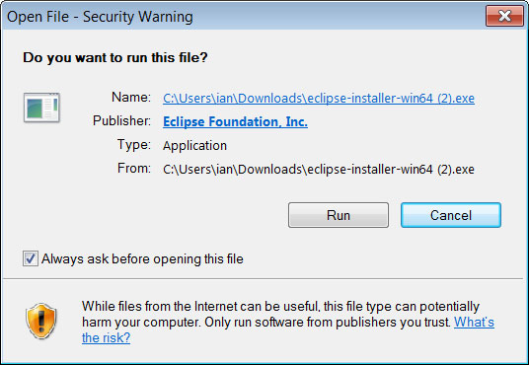

3. Select the package to install

The new Eclipse Installer shows the packages available to Eclipse users. You can search for the package

you want to install or scroll through the list.

Select and click on the package you want to install.

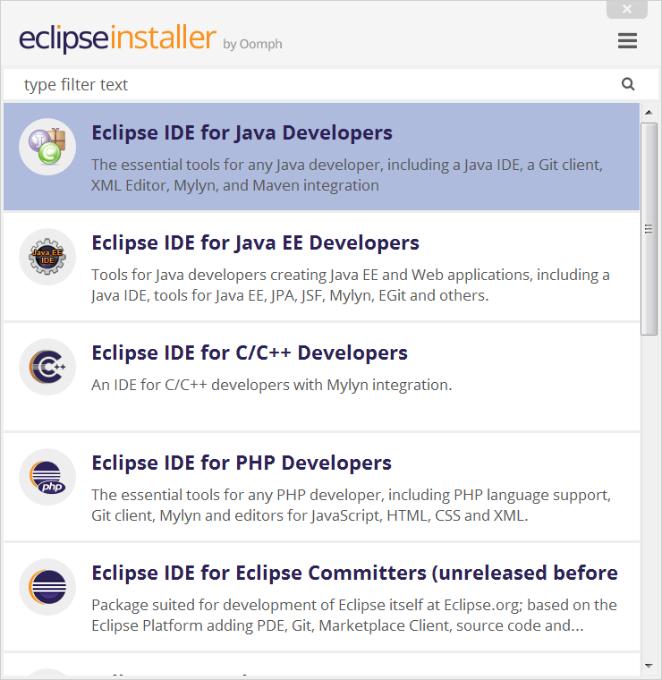

4. Select your installation folder

Specify the folder where you want Eclipse to be installed. The default folder will be in your User directory.

Select the ‘Install’ button to begin the installation.

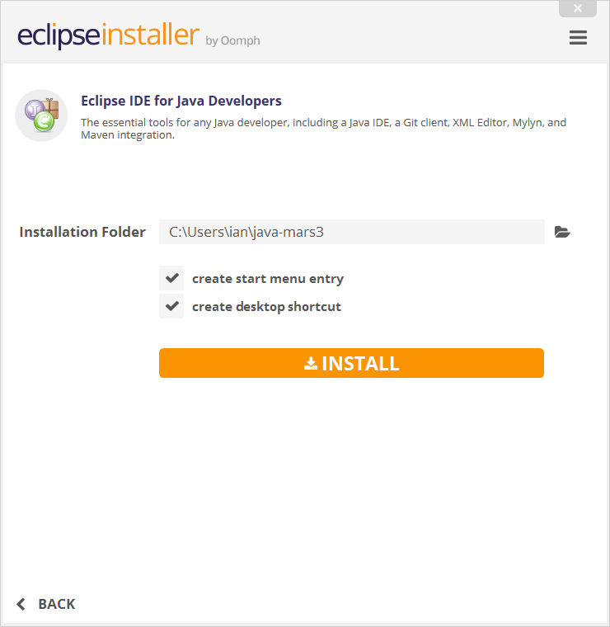

5. Launch Eclipse

Once the installation is complete you can now launch Eclipse.

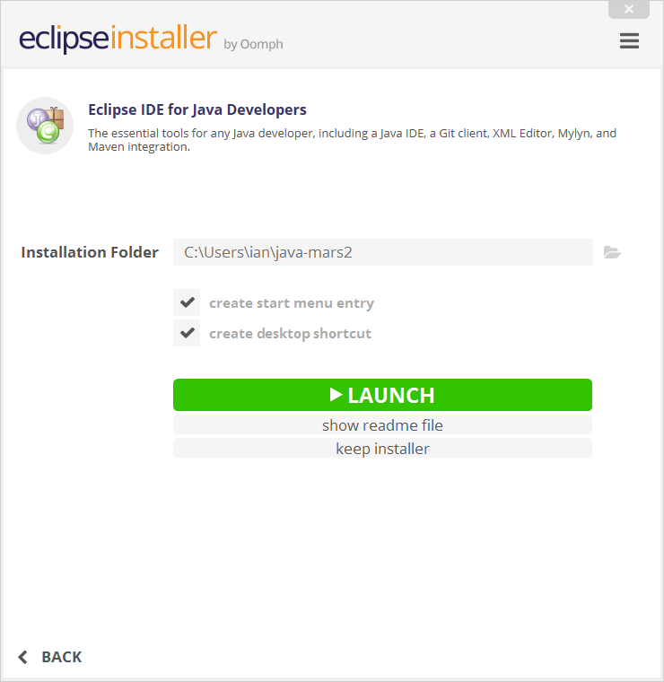

**SELENIUM INSTALLATION GUIDE:--->**

1. Open eclipse and create a new maven project.
2. Steps to create a maven project:

-Go to File--> NEW--> Project--> Maven(Maven Project)--> Create a simple project(Skip Archetype selection)--> Use default workspace location (If the location is not set please browse for it and set the location) --> Add project to working set.

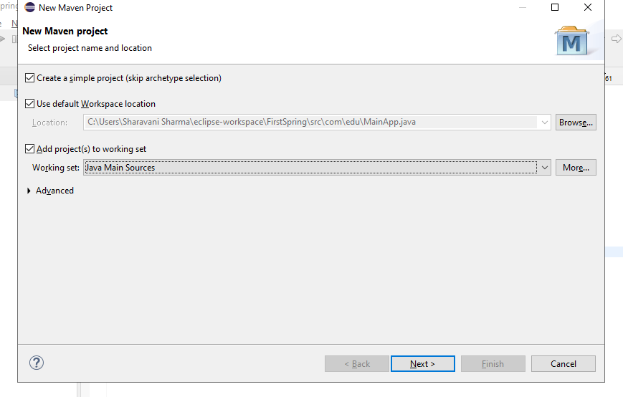

1. Give group id as co.edureka and Artifact id as Edureka and Name should be same as Artifact ID.

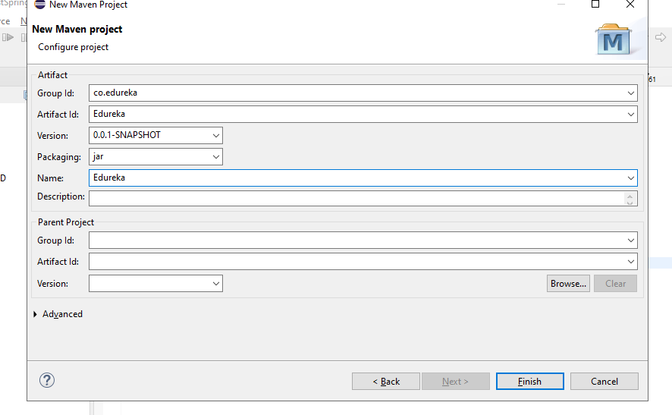

1. Now next step is to open Pom.xml file and add the below dependency in your Pom.xml file:

<dependencies>

<dependency>

<groupId>org.seleniumhq.selenium</groupId>

<artifactId>selenium-java</artifactId>

<version>4.3.0</version>

</dependency>

</dependencies>

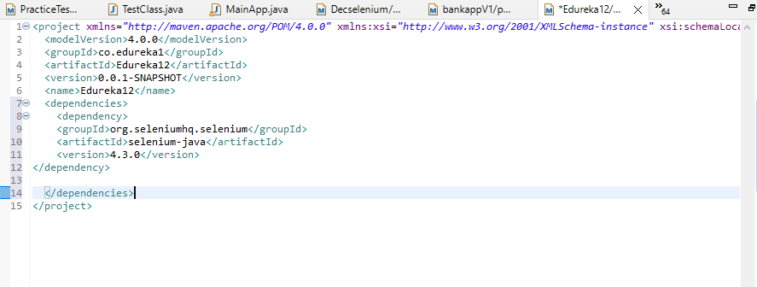

5.Next step is to check your browser version and download web driver of the same version (same as your browser version)

You can download the web driver from the below url:

<https://chromedriver.chromium.org/downloads>

Download it extract it and keep it in any drive in a new folder.

1. Go to eclipse Right click on your project and create a new folder ( new-->folder) and name it as Driver.

1. Now go to the location(to your drive where you have extract your web driver) where you have kept your Driver copy your driver by right clicking on the driver and then copy.
2. Go to eclipse and paste the driver in your folder (Driver).

